H.T No
Regulations:
A22

Sreenidhi Institute of Science and Technology
(An Autonomous Institution)
Code No:9K406 Date: 10-July-2025 (FN)

B.Tech II-Year II- Semester External Examination, July-2025 (Regular and Supplementary)
STRUCTURAL ANALYSIS-I (CIVIL)

Time: 3 Hours Max.Marks:60

Note: a) No additional answer sheets will be provided.
b) All sub-parts of a question must be answered at one place only, otherwise it will not be valued.
c) Missing data can be assumed suitably.
Bloom's Cognitive Levels of Learning (BCLL)

Remember | L1 | Apply | L3 | Evaluate | L5
Understand | L2 | Analyze | L4 | Create | L6

Part - A Max.Marks: 6x2=12

Answer all QUESTIONS, EACH QUESTION CARRIES 2 MARKS.

 |  | BCLL | CO(s) | Marks
1 | Define perfect frame. | L1 | CO1 | [2M]
2 | Write the uses of arches. | L2 | CO2 | [2M]
3 | Write down the equation used in three moment method. | L3 | CO3 | [2M]
4 | Explain advantages of continuous beam | L1 | CO4 | [2M]
5 | Write down the equation used in slope deflection method. | L1 | CO5 | [2M]
6 | Define ILD. | L2 | CO6 | [2M]

Part – B Max.Marks: 6x8=48
ANSWER ALL QUESTIONS. EACH QUESTION CARRIES 8 MARKS.

 |  | BCLL | CO(s) | Marks
7. | Find the forces in the members of truss shown in figure. The cross-sectional area and young’s modulus of all the members are the same.  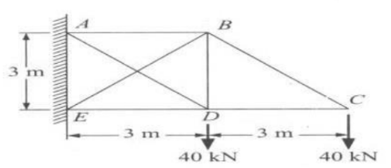 | L3 | CO1 | [8M]
 | OR
8 | Define frame, types of frames and methods of analysis of frames. | L2 | CO1 | [8M]
9. | Determine the deflection at the free end of the cantilever using strain energy method. Given E= 200GPa, I = 6.67 x 107mm⁴.  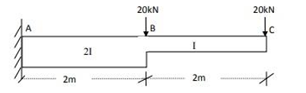 | L4 | CO2 | [8M]
 | OR
10 | What do you mean by arches how are they classify? Why are the arches preferred over beams? | L5 | CO2 | [8M]
11 | Analyse the Fixed Beam as shown in the figure below?  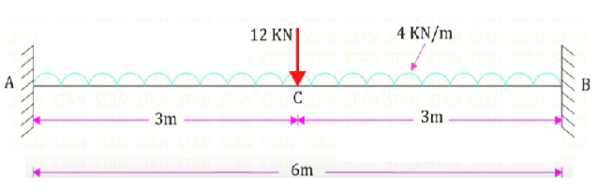 | L4 | CO3 | [8M]
 | OR
12 | Analyse the propped Cantilever as shown in the figure below?  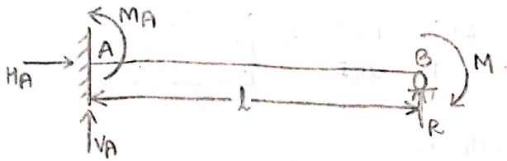 | L4 | CO3 | [8M]
13 | Analyse this beam using 3-moment method  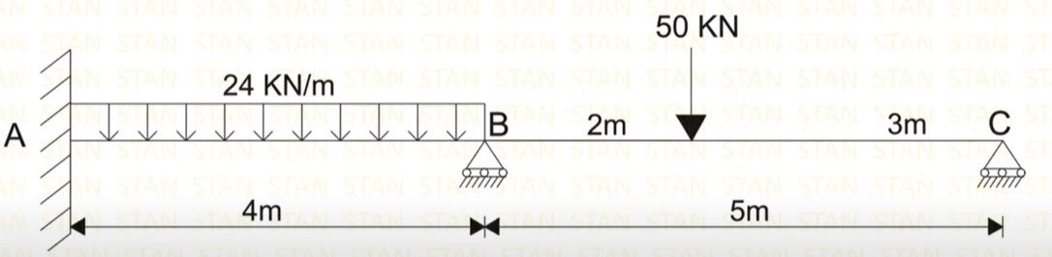 | L6 | CO4 | [8M]
 | OR
14 | Analyze this beam using Clapeyron's theorem of three moments. The support B sinks by 10mm, Take EI = 8000KNm²  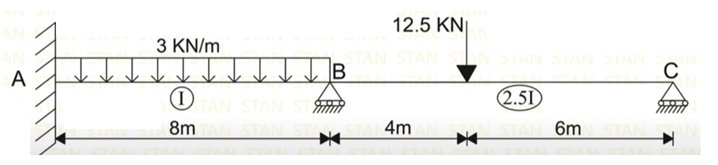 | L5 | CO4 | [8M]
15 | Analyse this frame using Slope Deflection Method. El is constant  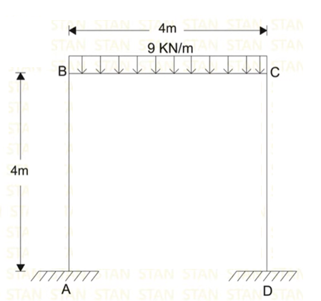 | L4 | CO5 | [8M]
 | OR
16 | Analyse this beam using Slope Deflection Method  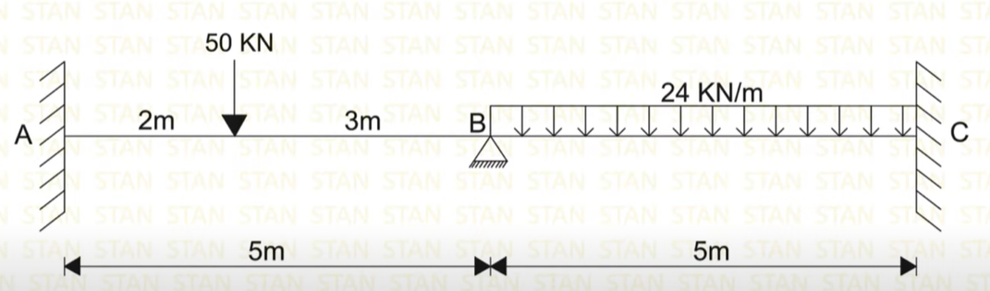 | L4 | CO5 | [8M]
17 | Write about Muller Breslau’s principle? Explain on focal length for beams.? | L2 | CO6 | [8M]
 | OR
18 | Draw ILD for propped cantilever beam of span 6m. Draw SFD and BMD | L3 | CO6 | [8M]

-- 00 -- 00 –

